Sample Randomly Generated Sudoku’s
Sudoku’s by: Joe Carlson, Max Beyer, Amy Loreen, Kyle Schaplowsky

Easy: Medium:
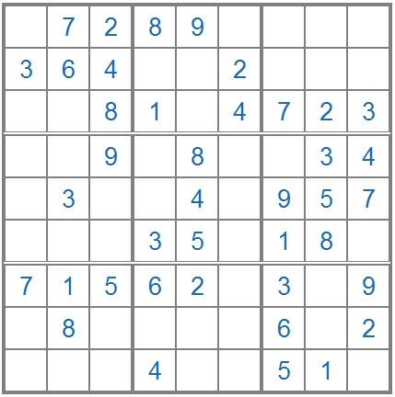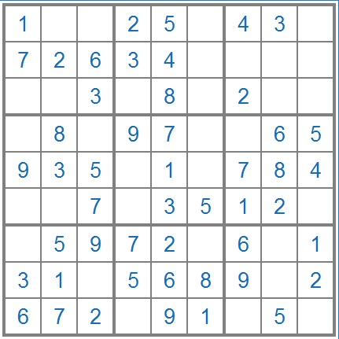

Hard: Insane:
